# Scott McPherson

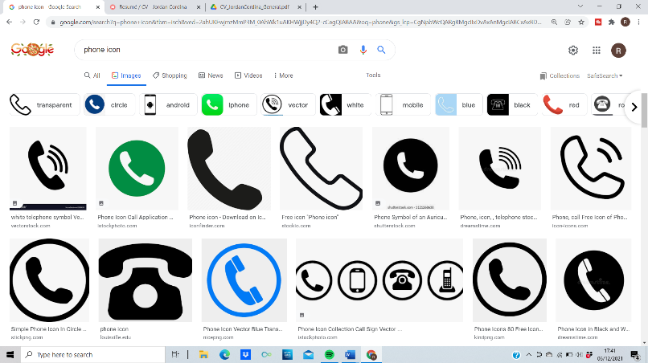

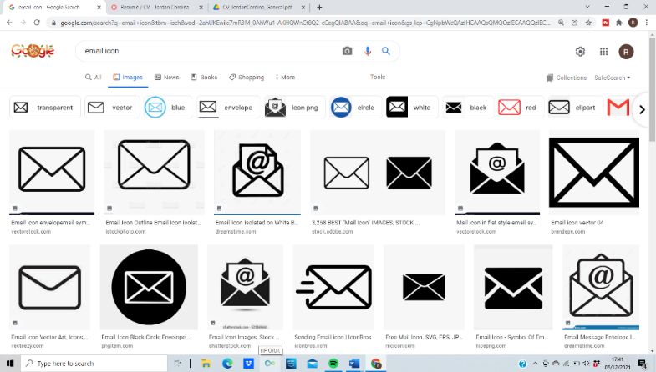 07951575489

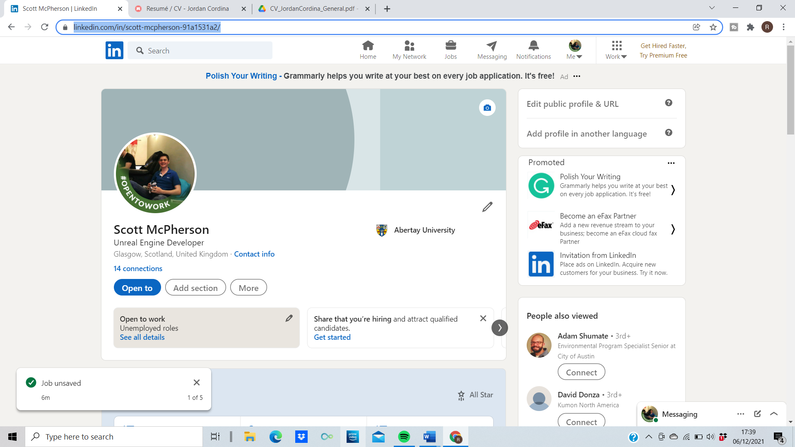 [Scottmcpherson56@gmail.com](mailto:Scottmcpherson56@gmail.com)

Location Icon Svg Png Icon Free Download (#292413) - OnlineWebFonts.COM [**https://www.linkedin.com/in/scott-mcpherson-91a1531a2/**](https://www.linkedin.com/in/scott-mcpherson-91a1531a2/)

 Glasgow, Scotland, United Kingdom

<https://github.com/scottmcpherson99>



<https://scottmcpherson56.wixsite.com/my-site>

I am a recent graduate of Computer Games Technology at Abertay University with a passion of programming video games. I would love the opportunity to be a part of a team responsible for delivering exciting and unique experiences to players.

## Software Experience

C++, Unreal Engine, GitHub, OpenGL, DirectX 11, Trello, Visual Studio 2015/17/19

## Work Experience

June 2021 – Nov 2021 **Unreal Developer** at **TransformologyXR**

* Constructing movement navigation for the user to move around
* Used the product configurator to allow the user to create the house of their choice
* Created tools to allow the designers to place in the game world to help the user navigate throughout the area

## Education

Sep 2017 – May 2021 **Bachelor of Computer Games Technology, Abertay University**

Classification: 2:1 (Upper Second)

* Dissertation “Designing an interface to help designers overcome the challenges with procedural generation”
* Available at - <https://github.com/scottmcpherson99/Interface-to-help-designers-use-procedural-generation.git>

# Projects

Jan 2022 – 2 Player Bomberman, (Unreal Engine 4, C++)  
Available at - <https://github.com/scottmcpherson99/BomberMan>

Jan 2020 – April 2020 – Telling the Bees, (Unreal Engine 4)

Available at - <https://github.com/Kacperbrozyna/DES310_Project_Source.git>

## Misc

**Favourite Games:** Minecraft, Call of Duty, FIFA, GTA, Clash of Clans, Mario Party, Football Manager, Among Us.

**Other:** Ex Captain of Junior Golf Team, Ex Pipe Sargent of 145th Glasgow Battalion Pipe Band, Achieved Queens Badge from Boy’s Brigade.